|  |  |
| --- | --- |
| **20CS2056L – Web Technology B5** | **URK20CS2100** |

|  |  |  |
| --- | --- | --- |
| **Ex. No. 4** | **RESPONSIVE WEB DESIGN USING BOOTSTRAP UI FRAMEWORK** | |
| Date of Exercise | 08/08/2022 | Website link: |

**Objective:**

To create a responsive web design using Bootstrap UI framework.

**Description:**

* Bootstrap is a free front-end framework for faster and easier web development
* Bootstrap includes HTML and CSS based design templates for typography, forms, buttons, tables, navigation, modals, image carousels and many other, as well as optional JavaScript plugins
* Bootstrap also gives you the ability to easily create responsive designs

**What is Responsive Web Design?**

Responsive web design is about creating web sites which automatically adjust themselves to look good on all devices, from small phones to large desktops.

**Setting the Viewport**

To create a responsive website, add the following <meta> tag to all your web pages:

<meta name="viewport" content="width=device-width, initial-scale=1">

**Where to Get Bootstrap 5**

Include the following tag in order to integrate Bootstrap 5  Framework in your web design.

<!-- Latest compiled and minified CSS -->  
<link href="https://cdn.jsdelivr.net/npm/bootstrap@5.1.3/dist/css/bootstrap.min.css" rel="stylesheet">  
<!-- Latest compiled JavaScript -->  
<script src="https://cdn.jsdelivr.net/npm/bootstrap@5.1.3/dist/js/bootstrap.bundle.min.js"></script>

**Bootstrap 5 Containers**

Containers are used to pad the content inside of them, and there are two container classes available:

The .container class provides a responsive fixed width container

<div class="container">  
  <h1>My First Bootstrap Page</h1>  
  <p>This is some text.</p>  
</div>

The .container-fluid class provides a full width container, spanning the entire width of the viewport

<div class="container-fluid">  
  <h1>My First Bootstrap Page</h1>  
  <p>This is some text.</p>  
</div>

**Bootstrap Spacing – Padding and Margin**

The classes are named using the format

          {property}{sides}-{size}

Where property is one of:

m - for classes that set margin

p - for classes that set padding

Where sides is one of:

t - for classes that set margin-top or padding-top

b - for classes that set margin-bottom or padding-bottom

s - for classes that set margin-left or padding-left

e - for classes that set margin-right or padding-right

x - for classes that set both *-left and *-right

y - for classes that set both *-top and *-bottom

blank - for classes that set a margin or padding on all 4 sides of the element

**Program:**

HTML :

<!DOCTYPE html>

<html lang="en">

<head>

<meta charset="UTF-8">

<meta http-equiv="X-UA-Compatible" content="IE=edge">

<meta name="viewport" content="width=device-width, initial-scale=1.0">

<title>KarunyaKoffee</title>

<h1 align="center">Karunya Koffee</h1>

<link rel="shortcut icon" href="https://th.bing.com/th/id/R.18692f5dd6525952db5ae1f9a22a129f?rik=cYFZZtMYv5h8UQ&riu=http%3a%2f%2flofrev.net%2fwp-content%2fphotos%2f2017%2f05%2fk_logo.png&ehk=gIeP7i%2fE3zgIJeNRRrYRDtkDiGBkojRdhGZR42U81c4%3d&risl=&pid=ImgRaw&r=0" type="image/x-icon">

<link href="https://cdn.jsdelivr.net/npm/bootstrap@5.0.2/dist/css/bootstrap.min.css" rel="stylesheet" integrity="sha384-EVSTQN3/azprG1Anm3QDgpJLIm9Nao0Yz1ztcQTwFspd3yD65VohhpuuCOmLASjC" crossorigin="anonymous">

<link rel="stylesheet" href="style.css">

<script src="https://cdn.jsdelivr.net/npm/bootstrap@5.0.2/dist/js/bootstrap.bundle.min.js" integrity="sha384-MrcW6ZMFYlzcLA8Nl+NtUVF0sA7MsXsP1UyJoMp4YLEuNSfAP+JcXn/tWtIaxVXM" crossorigin="anonymous"></script>

</head>

<body>

<nav class="navbar navbar-expand-lg navbar-light bg-dark">

<a class="navbar-brand m-3" href="#">

<img src="https://th.bing.com/th/id/OIP.5XM_G6bkYrwZ6xCHIG14_QHaFY?pid=ImgDet&rs=1" alt="WeGo" height="50" width="100">

</a>

<button class="navbar-toggler btn btn-info" type="button" data-bs-toggle="collapse" data-bs-target="#navbarSupportedContent" aria-controls="navbarSupportedContent" aria-expanded="false" aria-label="Toggle navigation">

<span class="navbar-toggler-icon"></span>

</button>

<div class="collapse navbar-collapse" id="navbarSupportedContent">

<ul class="navbar-nav ms-auto p-4">

<li class="nav-item">

<a class="nav-link" href="https://www.karunyakoffe.co.in/" target="_blank">Home</a>

</li>

<li class="nav-item">

<a class="nav-link" href="https://www.karunyakoffe.co.in/Menu" target="_blank">Menu</a>

</li>

<li class="nav-item">

<a class="nav-link" href="https://trains.karunyakoffe.com/?wego_click_id=9965aa8e-47cb-4a5a-a312-1ba2be9e200d" target="_blank">About us</a>

</li>

<li class="nav-item">

<a class="nav-link" href="https://blog.karunyakoffe.com/">Customer testimonials</a>

</li>

<li class="nav-item">

<a href="#" class="btn btn-primary">Login</a>

</li>

</ul>

</div>

</nav>

<div id="c" class="carousel slide" data-bs-ride="carousel">

<div class="carousel-inner">

<div class="carousel-item active">

<img src="https://wallpapercave.com/wp/wp3794530.jpg" height="700" class="d-block w-100" alt="...">

</div>

<div class="carousel-item">

<img src="https://wallpapercave.com/dwp2x/wp9906497.jpg" height="700" class="d-block w-100" alt="...">

</div>

<div class="carousel-item">

<img src="https://wallpapercave.com/wp/wp11391279.jpg" height="700" class="d-block w-100" alt="...">

</div>

</div>

<button class="carousel-control-prev" type="button" data-bs-target="#c" data-bs-slide="prev">

<span class="carousel-control-prev-icon" aria-hidden="true"></span>

<span class="visually-hidden">Previous</span>

</button>

<button class="carousel-control-next" type="button" data-bs-target="#c" data-bs-slide="next">

<span class="carousel-control-next-icon" aria-hidden="true"></span>

<span class="visually-hidden">Next</span>

</button>

</div>

<br>

<hr>

<div class="container-fluid p-10 m-10 ">

<div class="row" align="center">

<div class="col-sm-6 border border-primary m-2">

<h3 class="text-center text-primary mt-4">Your details</h3>

<form>

<div class="row mb-3">

<div class="col-sm-6">

<label for="tf1">Name:</label>

<input type="text" class="form-control" id="tf1">

</div>

<div class="col-sm-6">

<label for="tf2">Contact No::</label>

<input type="text" class="form-control" id="tf2">

</div>

</div>

<div class="row mb-3">

<div class="col-sm-12">

<label for="tf3">Feedback:</label>

<input type="text" class="form-control" placeholder="Address" id="tf3">

</div>

</div>

<div class="col-sm-4">

<label for="inputState">Branch:</label>

<select id="inputState" class="form-select">

<option selected>Karunya</option>

<option>Alanthurai</option>

<option>Gandhipiram</option>

</select><br>

<a href="#" class="btn btn-primary" align="center">Submit</a>

<br>

</div> <br>

</div>

</form>

</div>

</div> <br>

<div>

<iframe src="https://www.google.com/maps/embed?pb=!1m18!1m12!1m3!1d3917.3598829721873!2d76.74187231480222!3d10.936163992213242!2m3!1f0!2f0!3f0!3m2!1i1024!2i768!4f13.1!3m3!1m2!1s0x3ba866bd6aaaaaab%3A0xc650b8a75e7b51f0!2sKarunya%20Institute%20of%20Technology%20and%20Sciences%20(Deemed%20University)!5e0!3m2!1sen!2sin!4v1667480045975!5m2!1sen!2sin" width="600" height="450" style="border:0;" allowfullscreen="" loading="lazy" referrerpolicy="no-referrer-when-downgrade"></iframe>

</div>

</div>

</div>

</body>

</html>

**CSS :**

.navbar-light .navbar-nav .nav-link {

color: rgb(255, 255, 255);

}

.navbar-light .navbar-nav .nav-link:hover {

color: rgb(255, 0, 0);

}

body {

background-image: url('https://karunya.edu/sites/default/files/img/infra/webs/TOP-VIEW-LOW.jpg');

background-repeat: no-repeat;

background-attachment: fixed; background-size: cover;}

**Output:**

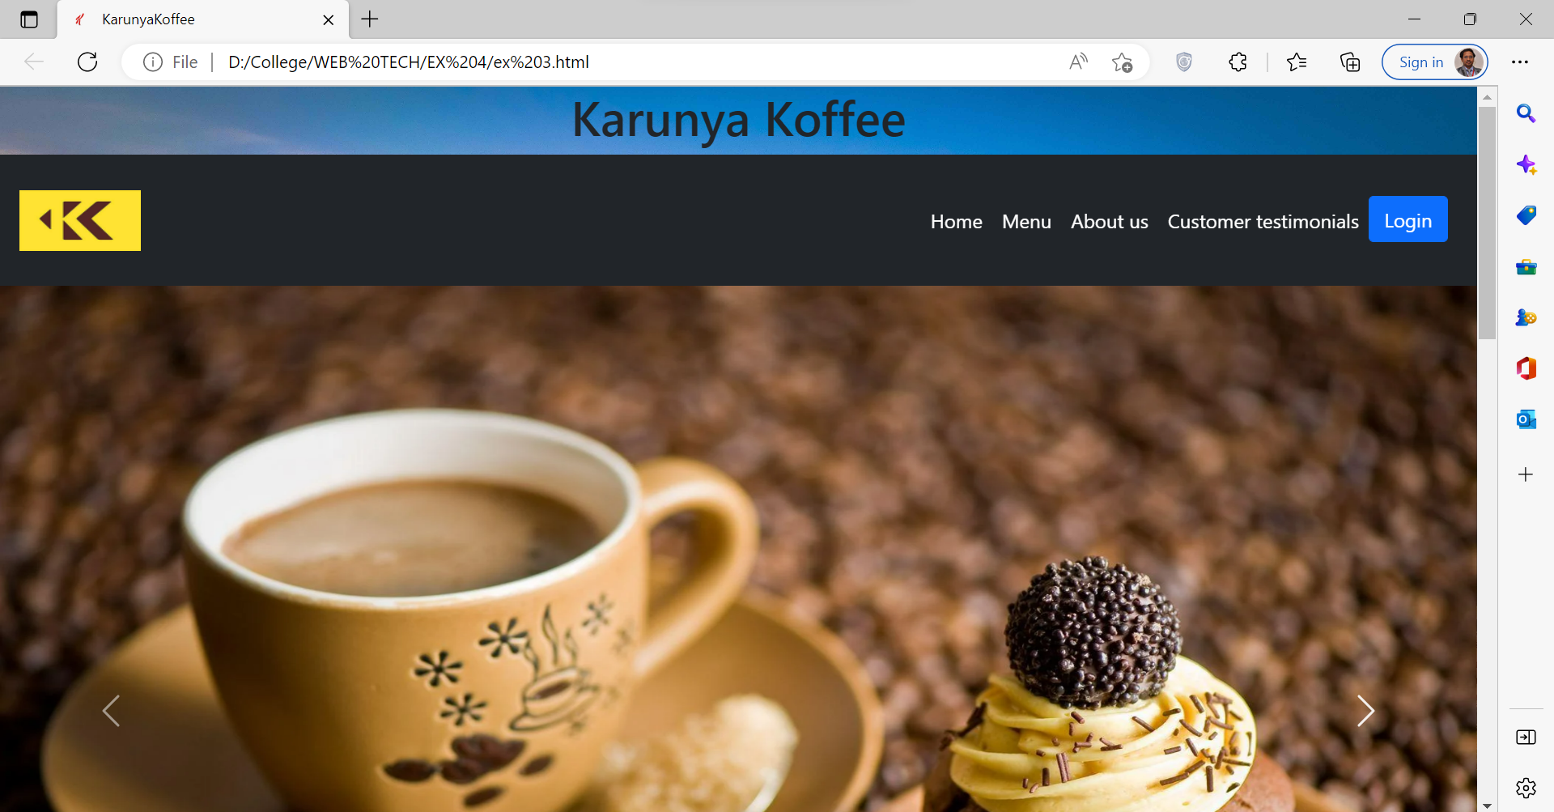

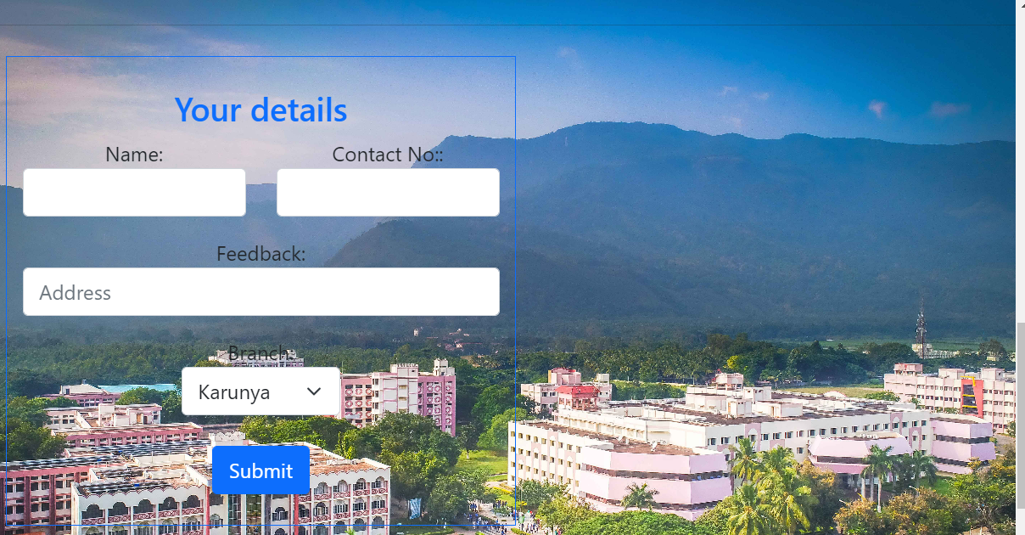

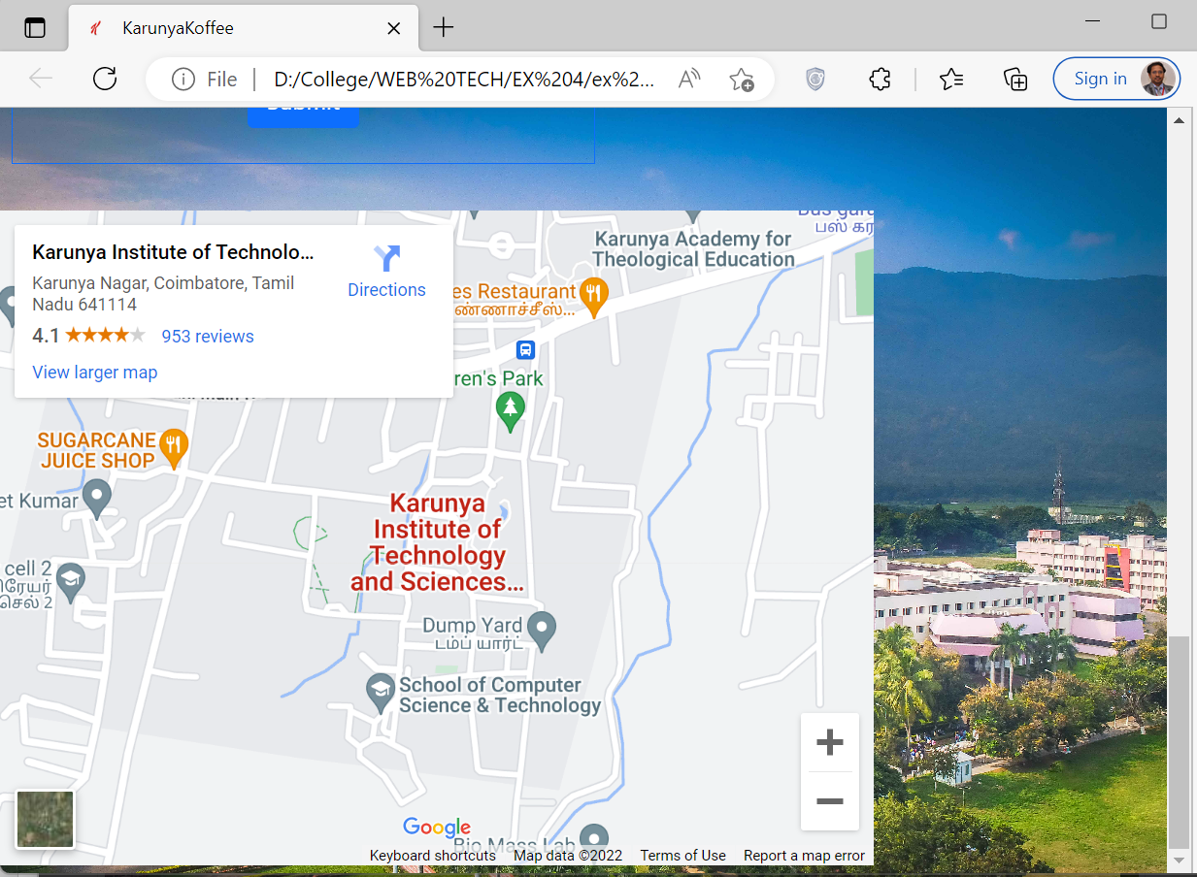

**Result:** We successfully created a responsive webpage using Bootstrap Framework .